**COVID-19 Trends and Impact in Africa (January 2020 – August 2021)**

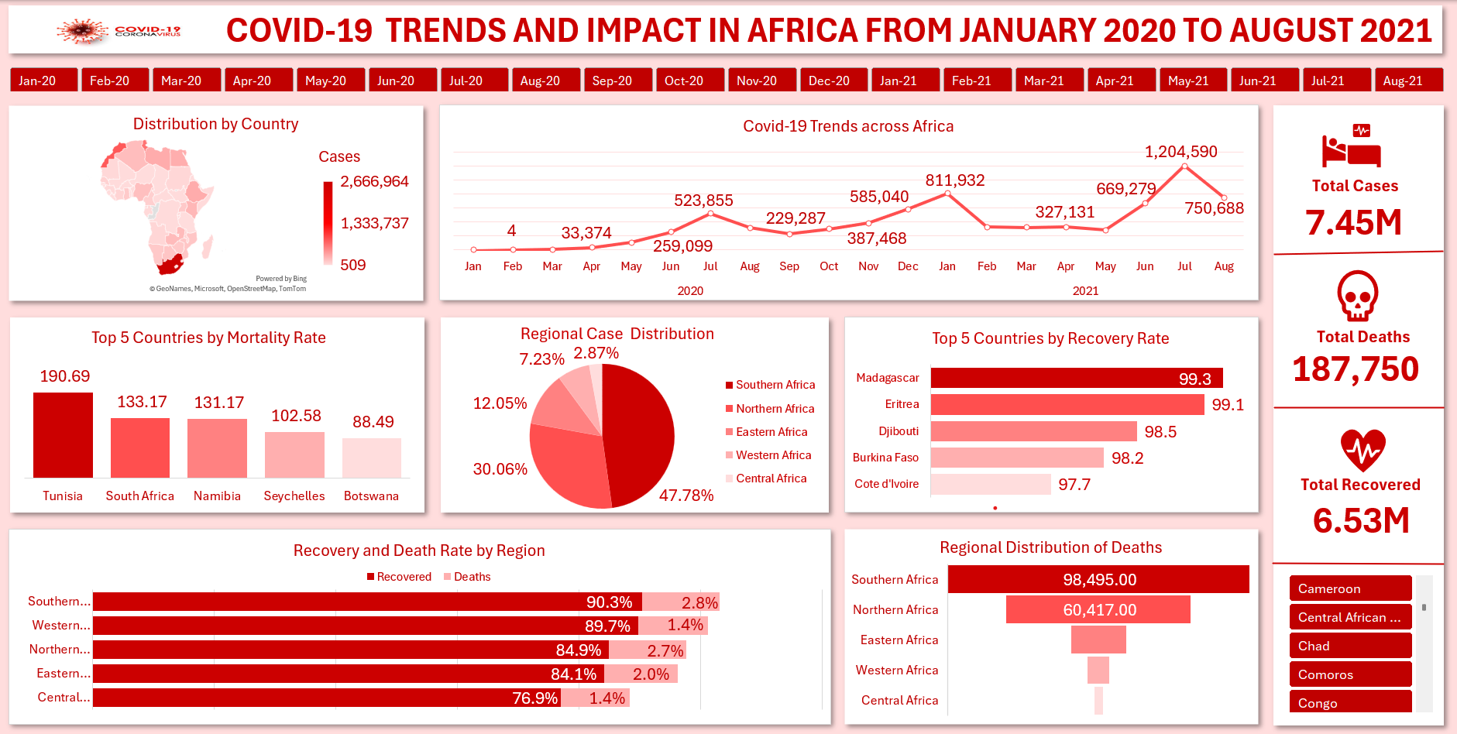

**Project Summary**

This project analyzes the spread, severity, and health outcomes of the COVID-19 pandemic across Africa from January 2020 to August 2021. Using confirmed cases, recoveries, and deaths recorded during the period, the study identifies trends, evaluates regional performance, and highlights disparities that shaped the pandemic's impact on African populations.

**Problem Statement**

The COVID-19 pandemic affected countries globally, but its progression in Africa followed a unique pattern influenced by testing capacity, healthcare infrastructure, demographics, and intervention strategies. Limited early surveillance and inconsistent reporting hindered timely response. There was a critical need to derive insights from available data to strengthen preparedness and improve health outcomes across the continent.

**Project Objectives**

1. Examine the timeline and progression of COVID-19 cases across Africa.
2. Identify countries and regions with the highest burden of infections and deaths.
3. Assess recovery and mortality outcomes geographically.
4. Draw insights on the effectiveness of national and regional response mechanisms.
5. Provide evidence-based recommendations for improving pandemic readiness.

**Industry Type**

Healthcare and Public Health Surveillance

**Stakeholders**

• Africa CDC  
• WHO Regional Office for Africa  
• Ministries of Health  
• Researchers and Epidemiologists  
• International Development Partners (UN, World Bank, NGOs)  
• Media and General Public

**Definition of Success**

Reduction in COVID-19 morbidity and mortality remains the ultimate indicator of public health success.

**Methodology**

The analysis was conducted using **Microsoft Excel** as part of my learning experience at Vephla University. The following approach was applied:

• **Data Cleaning and Structuring** using Power Query Editor  
• **Transformations**: Formatting date fields, removing duplicates, validating region/country entries  
• **Data Analysis Techniques**: Pivot tables, calculated fields, filtering, aggregation  
• **Visualizations**: Column charts, line charts, distribution maps  
• **Metrics Computed**: Recovery rates, mortality rates, regional share of cases/deaths

This methodology supported descriptive analytics focused on trend and comparative analysis.

**Story of the Data**

The dataset documents how COVID-19 emerged and spread across Africa, from sporadic early detections in early 2020 to multiple, more intense waves during 2021. It captures illness outcomes over time, highlighting the pandemic’s effects on different regions and populations.

**Data Structure**

**Category 1: Independent Variables**

• Date  
• Region  
• Country

**Category 2: Dependent Variables**

• Confirmed Cases  
• Recoveries  
• Deaths  
• Recovery Rate

**Analysis and Insights**

**1. COVID-19 Trends Across Africa**

**OBSERVATIONS**

1. A total of 7,458,156 cases were reported in Africa between January 2020 and August 2021.

2. Cases nearly doubled from 2.76 million at the end of 2020 to 4.70 million by August 2021

3. July 2021 recorded the highest number of cases (1,204,590)

4. Three distinct peaks are observed in the data, occurring in July 2020 (523,855), January 2021(811,932), and July 2021 (1,204,590), each indicating a significant surge in COVID-19 cases across Africa.

**PRE-INSIGHTS**

1. Africa experienced a delayed onset of COVID-19 compared to other continents, with cases remaining extremely low until March 2020.

2. The sharp increase from April to July 2020 indicates the first continental wave, driven by rising community transmission and increased testing capacity.

3. The rise in cases from October to December 2020 suggests a second wave likely linked to relaxed restrictions and cross-border movements.

4. July 2021 recorded the highest monthly total (1.2 million cases), representing the peak of Africa’s pandemic period, associated with the Delta variant.

5. Despite containment measures, 2021 cases exceeded 2020 totals.

**2. Distribution by Country**

**OBSERVATIONS**

1. South Africa recorded the highest number of cases (2,666,964) — far exceeding all other countries.

2. Other highly affected countries include Morocco (799,775), Tunisia (640,897), Ethiopia (293,737), Libya (293,532), and Egypt (285,995).

3. Nations such as Kenya, Zambia, Ghana, Nigeria, and Zimbabwe reported totals ranging between 100,000 to 230,000 cases.

4. Tanzania (509 cases), Sao Tome and Principe (2,517), Comoros (4,048), and Chad (4,984) reported the fewest cases

**PRE-INSIGHTS**

1. The wide variation in case numbers across countries may suggest uneven testing capacity, data transparency differences and epidemiological differences.

2. Countries with large urban centers and strong international travel links (e.g., South Africa, Egypt, Morocco) had higher exposure and case numbers, underscoring the role of mobility and trade networks in pandemic spread.

3. The pandemic revealed major differences in public health infrastructure, disease surveillance, and emergency coordination across African countries.

4. Nations that implemented early lockdowns, public communication campaigns, and targeted testing tended to control spread more effectively than those with delayed or inconsistent measures.

5. Exceptionally low case counts in a few countries likely reflect under-detection or alternative reporting approaches, which may have masked true transmission levels.

**3. Regional Case Distribution**

**OBSERVATIONS**

1. Southern Africa recorded the highest number of cases (3.56 million) accounting for nearly half of the continent’s total.

2. Northern Africa followed with 2.24 million cases, representing a major regional hotspot.

3. Eastern Africa reported 898,945 cases, showing a moderate burden compared to the north and south.

4. Western Africa recorded 539,373 cases.

5. Central Africa had the lowest total of 214,081 cases

**PRE-INSIGHTS**

1. Southern and Northern Africa together accounted for over 75% of all reported cases, probably due to regional differences in urbanization, mobility, and health system reporting capacity.

2. Higher testing and surveillance infrastructure in Southern and Northern Africa may have contributed to higher detected cases, while under-detection in Central and Western Africa is possible.

3. The most affected regions (Southern and Northern Africa) are also major economic and travel hubs, which likely accelerated transmission.

4. The regional spread may be a pointer to differences in health preparedness and response systems, suggesting that resource allocation and infrastructure significantly influenced outcomes.

**4. Regional Distribution of Deaths**

**OBSERVATIONS**

1. Southern Africa accounted for the highest share of deaths (98,495) representing more than half of all reported COVID-19 fatalities in Africa.

2. Northern Africa followed with 60,417 deaths , contributing nearly one-third of the continent’s total deaths.

3. Eastern Africa recorded 18,334 deaths while Western Africa reported 7,431 deaths approximately 9.77% and 3.96% of all deaths respectively.

4. Central Africa had 3,073 deaths accounting for the lowest proportion (1.64%) of total deaths .

5. The data shows a strong geographic concentration of fatalities in Southern and Northern Africa, with other regions contributing marginally.

**PRE-INSIGHTS**

1. Over 84% of Africa’s COVID-19 deaths occurred in Southern and Northern Africa, mirroring their higher infection rates and possibly more comprehensive reporting systems.

2. The high death proportions in these regions likely reflect hospital strain, higher comorbidity burdens, and aging populations, particularly in urban centers.

3. Lower-death regions such as Central and Western Africa may have experienced underreporting or limited cause-of-death verification, highlighting the need for better mortality surveillance.

4. Regions with higher testing and confirmed case counts (e.g., Southern Africa) naturally reported more deaths, suggesting that better surveillance reveals more accurate mortality trends.

5. The uneven death distribution may indicate inequalities in healthcare quality, access to critical care, and data management across African regions.

**5. Top 5 Countries by Mortality Rate**

**OBSERVATIONS**

1. Tunisia recorded the highest mortality rate (190.69 deaths per 100,000 population), making it the most severely affected country in Africa relative to population size.

2. South Africa (133.17) and Namibia (131.17) followed closely, showing similarly high mortality burdens.

3. Seychelles (102.58) and Botswana (88.49) also experienced high per-capita death rates despite smaller populations.

4. All five countries in the Top five are in Southern or Northern Africa

**PRE-INSIGHTS**

1. Countries like Tunisia, Seychelles, and South Africa faced higher exposure due to international travel, dense urbanization, and early variant introduction.

2. Elevated mortality rates indicate hospital capacity limits, particularly during the Delta variant surge, when demand for ICU care exceeded supply.

3. Higher mortality rates correlate with countries having stronger surveillance and diagnostic capacity, suggesting they captured the true scale of deaths more effectively.

4. Despite smaller populations, countries such as Seychelles and Botswana highlight how limited healthcare resources can quickly be overwhelmed in pandemics.

**6. Top 5 Countries by Recovery Rate**

**OBSERVATIONS**

1. Madagascar recorded the highest recovery rate at 99.3%

2. Eritrea recorded the second highest recovery rate at 99.1%

3. Djibouti was the third best performing country at 98.5%.

4. Burkina Faso at (98.2%) and Côte d'Ivoire at (97.7%) also demonstrated strong recovery outcomes as the fourth and fifth highest countries by recovery rate

**PRE-INSIGHTS**

1. All five countries maintained recovery rates above 97%, indicating relatively effective case management and possibly lower disease severity or early containment success.

2. Most of these countries experienced lower case volumes, allowing for more manageable healthcare workloads compared to heavily affected nations like South Africa or Tunisia.

3. The consistent high recovery rates suggest timely interventions and possible benefits from community-level health awareness and response systems.

4. Higher recoveries may be due to swift action with testing, isolation, and border control measures from countries

5. In a few countries, high recovery rates may partially reflect limited testing capacity or incomplete death reporting, highlighting the need for robust health data infrastructure.

6. Previous encounters with epidemics (e.g., Ebola, cholera) may have enhanced national and community-level outbreak response capacity.

**7. Recovery and Death Rate by Region**

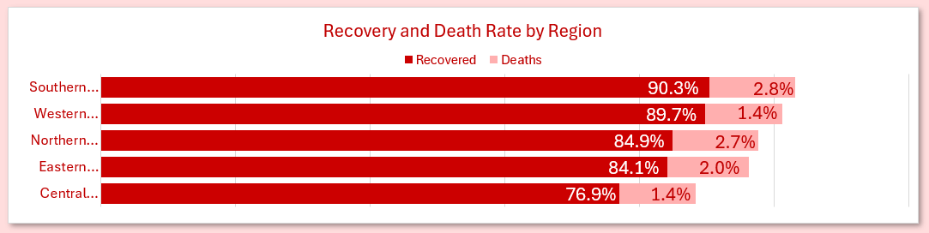

**OBSERVATIONS**

**1**. Southern Africa region recorded the highest recovery rate (90.3%), followed closely by Western Africa (89.7%).

2. Central Africa reported the lowest recovery rate (76.9%).

3. Southern Africa (2.8%) and Northern Africa (2.7%) had the highest death rates.

4. Central and Western Africa each recorded 1.4% death rates, while Eastern Africa reported 2.0%, showing moderate outcomes overall.

5. Recovery rates exceeded 75% across all regions, indicating that most infected individuals recovered.

**PRE-INSIGHTS**

1.Western Africa’s high recovery and low death rates point to effective case management and possibly younger population demographics.

2. The relatively higher death rates may reflect overburdened hospitals, higher testing rates, and better mortality documentation — not necessarily worse performance.

3. The combination of a low recovery rate and moderate death rate implies possible underreporting, limited treatment access, or delayed diagnosis.

4. The disparities reveal uneven access to healthcare, testing, and medical resources, emphasizing the need for regional investment balance.

5. The figures also reflect variations in data collection and case definition, strengthening surveillance systems is key for accuracy and decision-making.

**Post-Analysis Observations**

1. Africa experienced multiple waves with increasing impacts over time.
2. Southern and Northern Africa accounted for most infections and deaths.
3. Urbanization and mobility strongly influenced disease burden.
4. Mortality aligned with healthcare pressure and system resilience.
5. Regional outcomes varied due to surveillance, preparedness, and equity gaps.

**Recommendations**

**National Level**

• Strengthen hospital and laboratory systems  
• Institutionalize community health workers  
• Improve digital surveillance and data transparency  
• Increase innovation in vaccines and diagnostics  
• Mainstream pandemic preparedness in health policy

**Regional Level**

• Integrate cross-border early warning systems  
• Establish regional emergency response teams  
• Pool procurement and train healthcare workforce  
• Harmonize health data reporting standards

**Continental Level**

• Expand Africa CDC’s authority and capacity  
• Invest in Africa-based vaccine manufacturing  
• Create continental reserves of essential supplies  
• Apply predictive data analytics in outbreak planning  
• Advocate globally for fair vaccine access and health equity

**Conclusion**

COVID-19 posed a significant health challenge to Africa, demonstrating varying resilience across nations and regions. Pandemic severity increased through successive waves, particularly in 2021, exposing weaknesses in health systems and surveillance. However, strong recoveries in several countries and early containment in some regions show progress worth building upon. Strengthened preparedness, decentralized healthcare systems, and robust data capabilities remain essential to reduce mortality and improve response outcomes in future public health emergencies.

 Data Source: Humanitarian Emergency Response Agency  
 Reference: https://www.afro.who.int/news/africas-covid-19-surge-tops-second-wave-peak-vaccine-deliveries-pick